**Civil war in Georgia**

|  |  |
| --- | --- |
| **UNSC Resolution:** | **1187** |
| **Date of adoption:** | **30-July-1998** |
| **Operative paragraph:** | **2** |
| **Demand number:** | **1187.0x11** |

**David Siroky**

# Wording of demand

observe strictly the Moscow Agreement (S/1994/583, annex I) and also the ceasefire protocol signed on 25 May 1998, as well as all their obligations to refrain from the use of force and to resolve disputed issues by peaceful means only

# List of addressees of the demand

Government of Georgia, Abkhazia

# Short-term compliance

## Description of the addressee(s)’ conduct



s/1998/1012

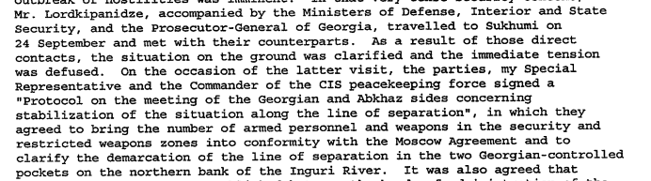

s/1998/1012

## Assessment

|  |  |  |  |
| --- | --- | --- | --- |
| ***Short-term compliance*** | | | |
| No or marginal compliance (1) | Medium low compliance (2) | Medium high compliance (3) | Full or almost full compliance (4) |

## Considerations underlying the assessment

# Medium-term compliance

## Description of the addressee(s)’ conduct

s/1999/60

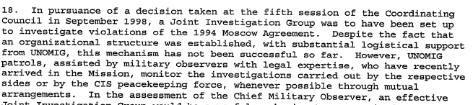

s/1990/60

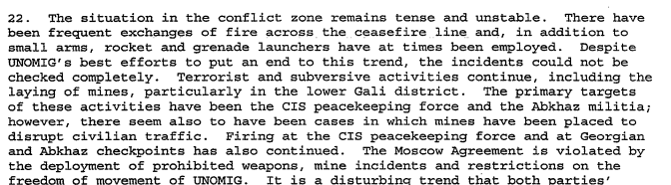

s/1990/60

|  |  |  |  |
| --- | --- | --- | --- |
| ***Medium-term compliance*** | | | |
| No or marginal compliance (1) | Medium low compliance (2) | Medium high compliance (3) | Full or almost full compliance (4) |

## Considerations underlying the assessment

# Depth of demand

## Assessment

|  |  |  |
| --- | --- | --- |
| ***Level of depth of demand*** | | |
| Low depth of demand (1) | Medium depth of demand (2) | High depth of demand (3) |

## Considerations underlying the assessment

# Level of confidence about coding decisions

|  |  |  |
| --- | --- | --- |
| ***Level of confidence about coding decision*** | | |
| Extremely high | High | Moderate |

# Comments to IPI (if any)

**Civil war in Georgia**

|  |  |
| --- | --- |
| **UNSC Resolution:** | **1187** |
| **Date of adoption:** | **30-July-1998** |
| **Operative paragraph:** | **3** |
| **Demand number:** | **1187.0x11** |

**David Siroky**

# Wording of demand

fulfil obligations in regard to the right of all refugees and displaced persons to return to their homes in secure conditions in accordance with international law and as set out in the Quadripartite Agreement (S/1994/397, annex II), especially after the significant outflow of refugees resulting from the recent hostilities

# List of addressees of the demand

Government of Georgia, Abkhazia

# Short-term compliance

## Description of the addressee(s)’ conduct

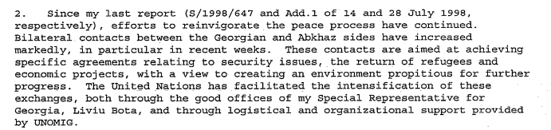

s/1998/1012

## Assessment

|  |  |  |  |
| --- | --- | --- | --- |
| ***Short-term compliance*** | | | |
| No or marginal compliance (1) | Medium low compliance (2) | Medium high compliance (3) | Full or almost full compliance (4) |

## Considerations underlying the assessment

# Medium-term compliance

## Description of the addressee(s)’ conduct

s/1999/60

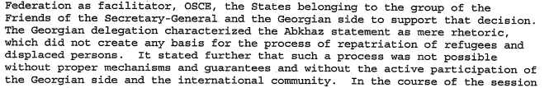

s/1990/60

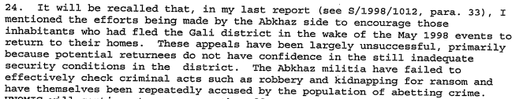

s/1999/60



s/1999/60

## Assessment

|  |  |  |  |
| --- | --- | --- | --- |
| ***Medium-term compliance*** | | | |
| No or marginal compliance (1) | Medium low compliance (2) | Medium high compliance (3) | Full or almost full compliance (4) |

## Considerations underlying the assessment

# Depth of demand

## Assessment

|  |  |  |
| --- | --- | --- |
| ***Level of depth of demand*** | | |
| Low depth of demand (1) | Medium depth of demand (2) | High depth of demand (3) |

## Considerations underlying the assessment

# Level of confidence about coding decisions

|  |  |  |
| --- | --- | --- |
| ***Level of confidence about coding decision*** | | |
| Extremely high | High | Moderate |

# Comments to IPI (if any)

**Civil war in Georgia**

|  |  |
| --- | --- |
| **UNSC Resolution:** | **1187** |
| **Date of adoption:** | **30-July-1998** |
| **Operative paragraph:** | **3** |
| **Demand number:** | **1187.0311** |

**David Siroky**

# Wording of demand

allow the unconditional and immediate return of all persons displaced since the resumption of hostilities in May 1998

# List of addressees of the demand

Abkhazia

# Short-term compliance

## Description of the addressee(s)’ conduct

s/1999/60



s/1999/60

## Assessment

|  |  |  |  |
| --- | --- | --- | --- |
| ***Short-term compliance*** | | | |
| No or marginal compliance (1) | Medium low compliance (2) | Medium high compliance (3) | Full or almost full compliance (4) |

## Considerations underlying the assessment

# Medium-term compliance

## Description of the addressee(s)’ conduct

s/1999/60



s/1990/60



s/1999/60

## Assessment

|  |  |  |  |
| --- | --- | --- | --- |
| ***Medium-term compliance*** | | | |
| No or marginal compliance (1) | Medium low compliance (2) | Medium high compliance (3) | Full or almost full compliance (4) |

## Considerations underlying the assessment

# Depth of demand

## Assessment

|  |  |  |
| --- | --- | --- |
| ***Level of depth of demand*** | | |
| Low depth of demand (1) | Medium depth of demand (2) | High depth of demand (3) |

## Considerations underlying the assessment

# Level of confidence about coding decisions

|  |  |  |
| --- | --- | --- |
| ***Level of confidence about coding decision*** | | |
| Extremely high | High | Moderate |

# Comments to IPI (if any)

**Civil war in Georgia**

|  |  |
| --- | --- |
| **UNSC Resolution:** | **1187** |
| **Date of adoption:** | **30-July-1998** |
| **Operative paragraph:** | **8** |
| **Demand number:** | **1187.0811** |

**David Siroky**

# Wording of demand

display without delay the necessary political will to achieve substantial results on key issues of the negotiations, with full respect for the sovereignty and territorial integrity of Georgia, within the framework of the UN-led peace process and through direct dialogue, and to cooperate fully with the SG and his Special Representative, with the assistance of the Russian Federation as facilitator, as well as the group of Friends of the Secretary-General and of the OSCE

# List of addressees of the demand

Government of Georgia, Abkhazia

# Short-term compliance

## Description of the addressee(s)’ conduct

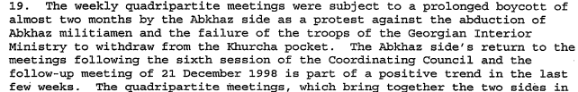

s/1999/60

## Assessment

|  |  |  |  |
| --- | --- | --- | --- |
| ***Short-term compliance*** | | | |
| No or marginal compliance (1) | Medium low compliance (2) | Medium high compliance (3) | Full or almost full compliance (4) |

## Considerations underlying the assessment

# Medium-term compliance

## Description of the addressee(s)’ conduct

s/1999/60

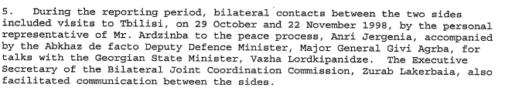

s/1999/60

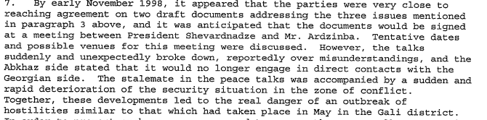

s/1999/60



s/1999/60

## Assessment

|  |  |  |  |
| --- | --- | --- | --- |
| ***Medium-term compliance*** | | | |
| No or marginal compliance (1) | Medium low compliance (2) | Medium high compliance (3) | Full or almost full compliance (4) |

## Considerations underlying the assessment

# Depth of demand

## Assessment

|  |  |  |
| --- | --- | --- |
| ***Level of depth of demand*** | | |
| Low depth of demand (1) | Medium depth of demand (2) | High depth of demand (3) |

## Considerations underlying the assessment

# Level of confidence about coding decisions

|  |  |  |
| --- | --- | --- |
| ***Level of confidence about coding decision*** | | |
| Extremely high | High | Moderate |

# Comments to IPI (if any)

**Civil war in Georgia**

|  |  |
| --- | --- |
| **UNSC Resolution:** | **1187** |
| **Date of adoption:** | **30-July-1998** |
| **Operative paragraph:** | **9** |
| **Demand number:** | **1187.0911** |

**David Siroky**

# Wording of demand

continue and increase active engagement in the negotiation process begun in Geneva on 23-25 July 1998, initiated by the SG aimed at achieving a comprehensive political settlement

# List of addressees of the demand

Government of Georgia, Abkhazia

# Short-term compliance

## Description of the addressee(s)’ conduct



s/1999/60



s/1999/60

## Assessment

|  |  |  |  |
| --- | --- | --- | --- |
| ***Short-term compliance*** | | | |
| No or marginal compliance (1) | Medium low compliance (2) | Medium high compliance (3) | Full or almost full compliance (4) |

## Considerations underlying the assessment

# Medium-term compliance

## Description of the addressee(s)’ conduct



s/1999/60



s/1999/60

## Assessment

|  |  |  |  |
| --- | --- | --- | --- |
| ***Medium-term compliance*** | | | |
| No or marginal compliance (1) | Medium low compliance (2) | Medium high compliance (3) | Full or almost full compliance (4) |

## Considerations underlying the assessment

# Depth of demand

## Assessment

|  |  |  |
| --- | --- | --- |
| ***Level of depth of demand*** | | |
| Low depth of demand (1) | Medium depth of demand (2) | High depth of demand (3) |

## Considerations underlying the assessment

# Level of confidence about coding decisions

|  |  |  |
| --- | --- | --- |
| ***Level of confidence about coding decision*** | | |
| Extremely high | High | Moderate |

# Comments to IPI (if any)

# to IPI (if any)

**Civil war in Georgia**

|  |  |
| --- | --- |
| **UNSC Resolution:** | **1187** |
| **Date of adoption:** | **30-July-1998** |
| **Operative paragraph:** | **10** |
| **Demand number:** | **1187.1011** |

**David Siroky**

# Wording of demand

coordinate efforts to implement fully and without delay existing commitments to ensure the security and safety of international personnel, including the creation of a joint mechanism for investigation and prevention of acts that represent violations of the Moscow Agreement and terrorist acts in the zone of conflict

# List of addressees of the demand

Government of Georgia, Abkhazia

# Short-term compliance

## Description of the addressee(s)’ conduct



s/1990/60

## Assessment

|  |  |  |  |
| --- | --- | --- | --- |
| ***Short-term compliance*** | | | |
| No or marginal compliance (1) | Medium low compliance (2) | Medium high compliance (3) | Full or almost full compliance (4) |

## Considerations underlying the assessment

# Medium-term compliance

## Description of the addressee(s)’ conduct



s/1990/60



s/1990/60

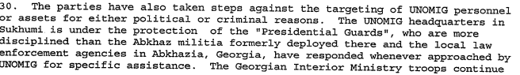

s/1999/60

## Assessment

|  |  |  |  |
| --- | --- | --- | --- |
| ***Medium-term compliance*** | | | |
| No or marginal compliance (1) | Medium low compliance (2) | Medium high compliance (3) | Full or almost full compliance (4) |

## Considerations underlying the assessment

# Depth of demand

## Assessment

|  |  |  |
| --- | --- | --- |
| ***Level of depth of demand*** | | |
| Low depth of demand (1) | Medium depth of demand (2) | High depth of demand (3) |

## Considerations underlying the assessment

# Level of confidence about coding decisions

|  |  |  |
| --- | --- | --- |
| ***Level of confidence about coding decision*** | | |
| Extremely high | High | Moderate |

# Comments to IPI (if any)

**Civil war in Georgia**

|  |  |
| --- | --- |
| **UNSC Resolution:** | **1187** |
| **Date of adoption:** | **30-July-1998** |
| **Operative paragraph:** | **11** |
| **Demand number:** | **1187.1111** |

**David Siroky**

# Wording of demand

take determined measures to put a stop to such acts which subvert the peace process (in particular the Georgian authorities)

# List of addressees of the demand

Government of Georgia, Abkhazia

# Short-term compliance

## Description of the addressee(s)’ conduct

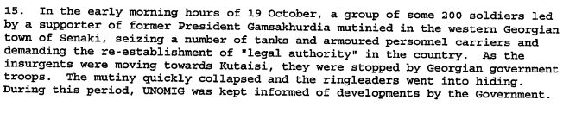

s/1998/1012

## Assessment

|  |  |  |  |
| --- | --- | --- | --- |
| ***Short-term compliance*** | | | |
| No or marginal compliance (1) | Medium low compliance (2) | Medium high compliance (3) | Full or almost full compliance (4) |

## Considerations underlying the assessment

# Medium-term compliance

## Description of the addressee(s)’ conduct

1. s/1999/60



s/1999/60



s/1990/60



s/1999/60

## Assessment

|  |  |  |  |
| --- | --- | --- | --- |
| ***Medium-term compliance*** | | | |
| No or marginal compliance (1) | Medium low compliance (2) | Medium high compliance (3) | Full or almost full compliance (4) |

## Considerations underlying the assessment

# Depth of demand

## Assessment

|  |  |  |
| --- | --- | --- |
| ***Level of depth of demand*** | | |
| Low depth of demand (1) | Medium depth of demand (2) | High depth of demand (3) |

## Considerations underlying the assessment

# Level of confidence about coding decisions

|  |  |  |
| --- | --- | --- |
| ***Level of confidence about coding decision*** | | |
| Extremely high | High | Moderate |

# Comments to IPI (if any)

**Civil war in Georgia**

|  |  |
| --- | --- |
| **UNSC Resolution:** | **1187** |
| **Date of adoption:** | **30-July-1998** |
| **Operative paragraph:** | **12** |
| **Demand number:** | **1187.1211** |

**David Siroky**

# Wording of demand

facilitate the implementation of practical measures resulting from the SG-initiated review of the security of UNOMIG

# List of addressees of the demand

Government of Georgia, Abkhazia

# Short-term compliance

## Description of the addressee(s)’ conduct



s/1990/60

## Assessment

|  |  |  |  |
| --- | --- | --- | --- |
| ***Short-term compliance*** | | | |
| No or marginal compliance (1) | Medium low compliance (2) | Medium high compliance (3) | Full or almost full compliance (4) |

## Considerations underlying the assessment

# Medium-term compliance

## Description of the addressee(s)’ conduct

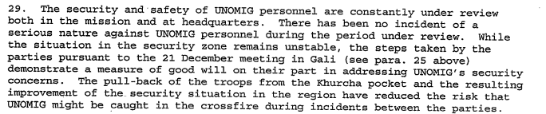

s/1999/60



s/1999/60

## Assessment

|  |  |  |  |
| --- | --- | --- | --- |
| ***Medium-term compliance*** | | | |
| No or marginal compliance (1) | Medium low compliance (2) | Medium high compliance (3) | Full or almost full compliance (4) |

## Considerations underlying the assessment

# Depth of demand

## Assessment

|  |  |  |
| --- | --- | --- |
| ***Level of depth of demand*** | | |
| Low depth of demand (1) | Medium depth of demand (2) | High depth of demand (3) |

## Considerations underlying the assessment

# Level of confidence about coding decisions

|  |  |  |
| --- | --- | --- |
| ***Level of confidence about coding decision*** | | |
| Extremely high | High | Moderate |

# Comments to IPI (if any)

**Civil war in Georgia**

|  |  |
| --- | --- |
| **UNSC Resolution:** | **1187** |
| **Date of adoption:** | **30-July-1998** |
| **Operative paragraph:** | **13** |
| **Demand number:** | **1187.1311** |

**David Siroky**

# Wording of demand

cease mass media campaign launched in Abkhazia and acts of harassment against UNOMIG

# List of addressees of the demand

Abkhazia

# Short-term compliance

## Description of the addressee(s)’ conduct



s/1999/60

## Assessment

|  |  |  |  |
| --- | --- | --- | --- |
| ***Short-term compliance*** | | | |
| No or marginal compliance (1) | Medium low compliance (2) | Medium high compliance (3) | Full or almost full compliance (4) |

## Considerations underlying the assessment

# Medium-term compliance

## Description of the addressee(s)’ conduct



s/1999/60

## Assessment

|  |  |  |  |
| --- | --- | --- | --- |
| ***Medium-term compliance*** | | | |
| No or marginal compliance (1) | Medium low compliance (2) | Medium high compliance (3) | Full or almost full compliance (4) |

## Considerations underlying the assessment

# Depth of demand

## Assessment

|  |  |  |
| --- | --- | --- |
| ***Level of depth of demand*** | | |
| Low depth of demand (1) | Medium depth of demand (2) | High depth of demand (3) |

## Considerations underlying the assessment

# Level of confidence about coding decisions

|  |  |  |
| --- | --- | --- |
| ***Level of confidence about coding decision*** | | |
| Extremely high | High | Moderate |

# Comments to IPI (if any)